**WAEX Filing Program- Input New PO#**

1. 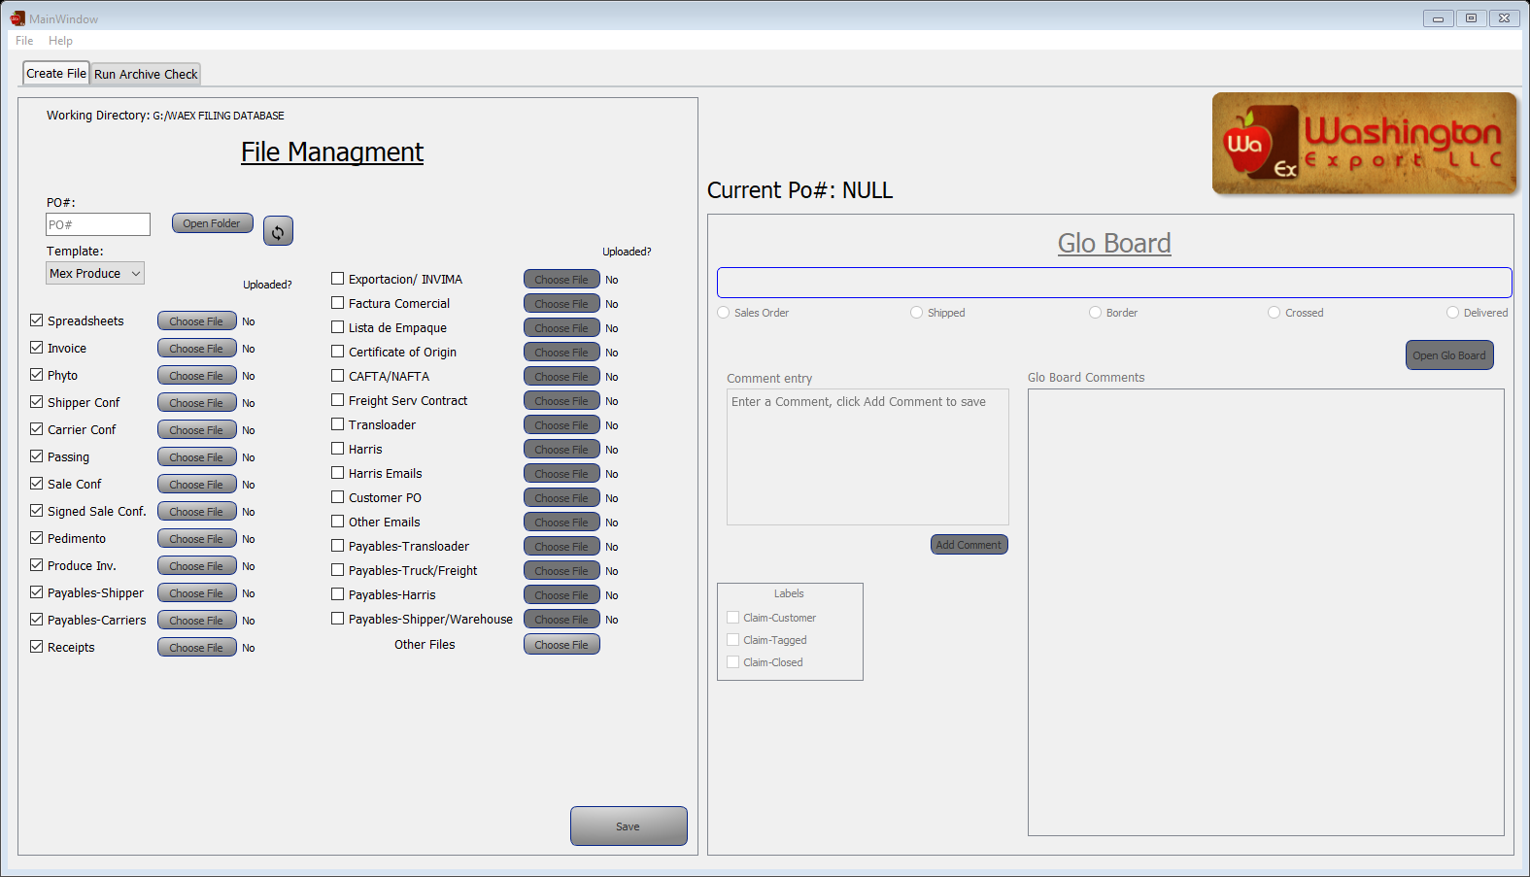

**5.** Upload files

**4.**  Change any required files if necessary

**6.**  Click Save

**3.**  Select template

**1.**Input PO#

**2.**Click enter